LOFT 102
2 BEDROOMS 1 BATH 2448 Sq. Ft

DOWNSTAIRS

LARGE MEDIA ROOM

BEDROOM 2
12´ 1´´ X 8´ 6´´

MASTER BEDROOM 15´3´´ X 12´ 8´´

LIVING/DINING
21´ 3´´ X 19´ 9´´

LARGE STUDY
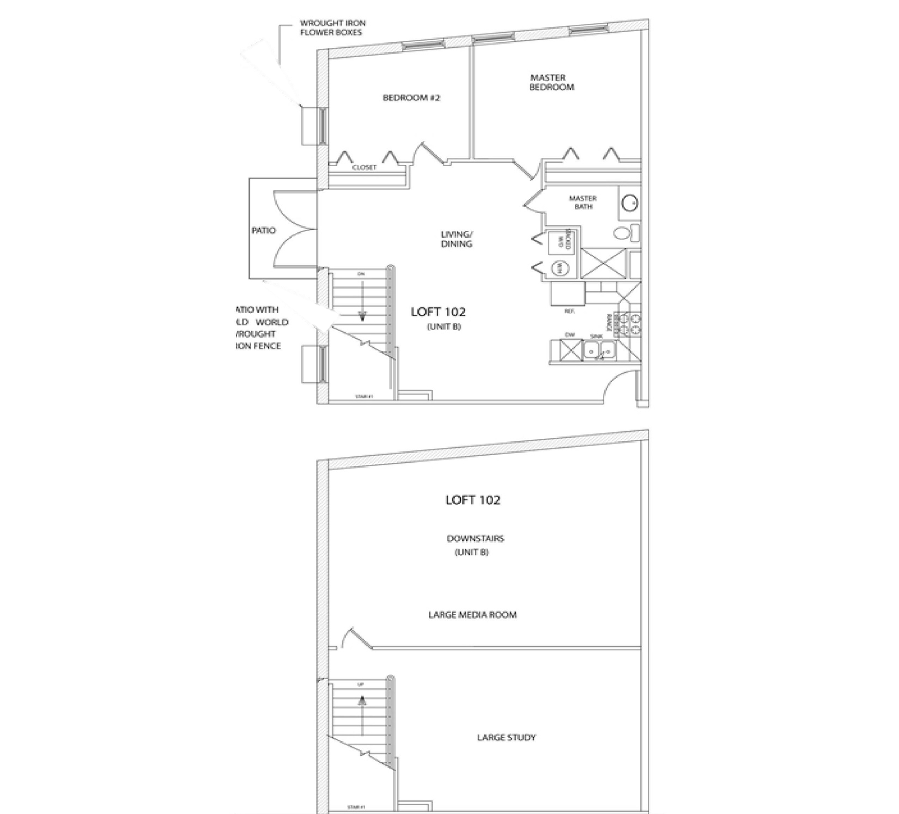

LOFT 104
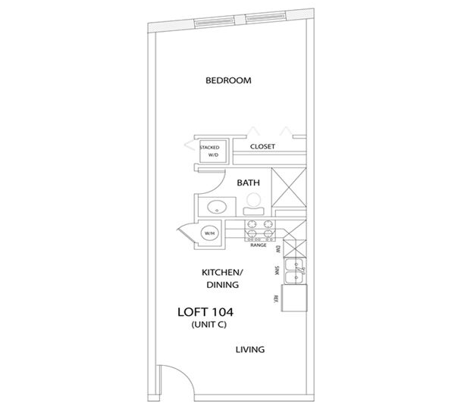
1 BEDROOM 1 BATH 577 Sq. Ft

BEDROOM
13´ 9´´ X 11´ 2´´

LIVING/DINING
13 ´ 9´´ X 18´ 3´´

LOFT 106
1 BEDROOM 1 BATH 590 Sq. Ft

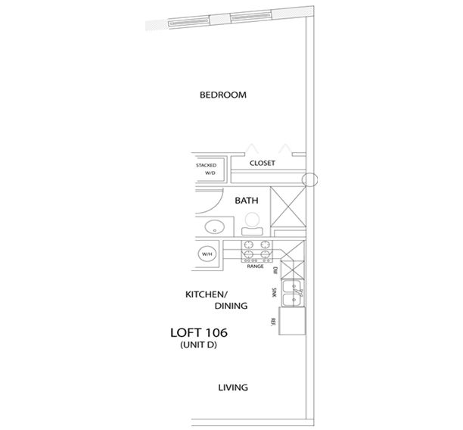

BEDROOM
13 ´ 9´´ X 18´ 3´´

LIVING/DINING
13 ´ 9´´ X 18´ 3´´

LOFT 201
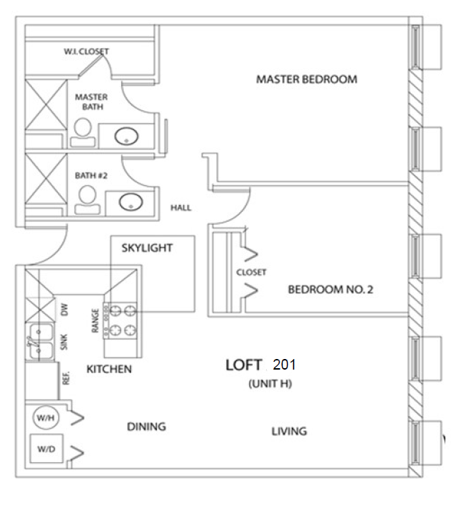
2 BEDROOMS 2 BATHS 994 Sq. Ft.

LIVING/DINING
27´ 5´´ X 11´ 1´´

BEDROOM 2
13´ 11´´ X 11´ 18´´

MASTER BEDROOM
13´11´´ X 11´ 8´´

LOFT 202
1 BEDROOM 1 BATH 994 Sq. Ft.

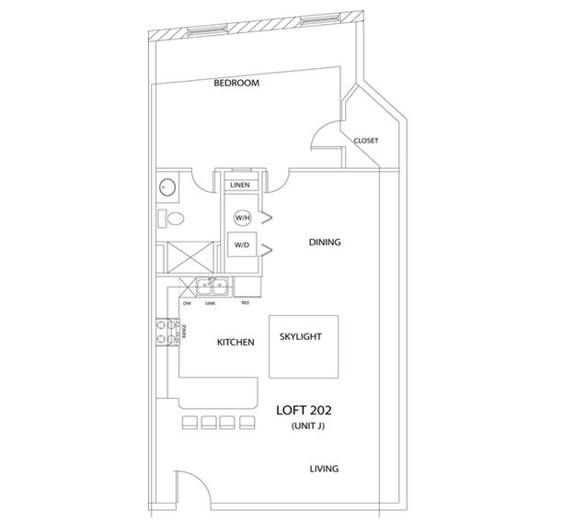

SKYLIGHT

LIVING/DINING
12´ 2´´ X 44´ 7´´

BEDROOM
18´ 5´´ X 16´ 1´´

LOFT 203
2 BEDROOMS 2 BATHS 1073 Sq. Ft.

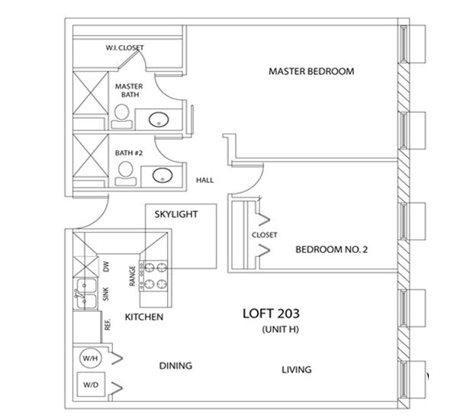

LIVING/DINING
28´ 3´´ X 13´ 1´´

BEDROOM 2
11´ 4´´ X 10´ 13´´

MASTER BEDROOM
18´12´´ X 12´ 4´´

LOFT 205
2 BEDROOMS 2 BATHS 1358 Sq. Ft.

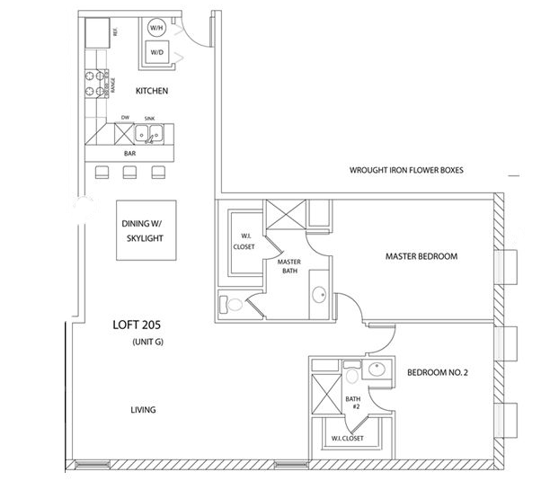

SKYLIGHT

LIVING/DINING
23´ 9´´ X 44´ 7´´

MASTER BEDROOM
14´ 9´´ X 12´ 4´´

BEDROOM 2
10´ 3´´ X 13´ 8´´

LOFT 206
1 BEDROOM 1 BATH 628 Sq. Ft.

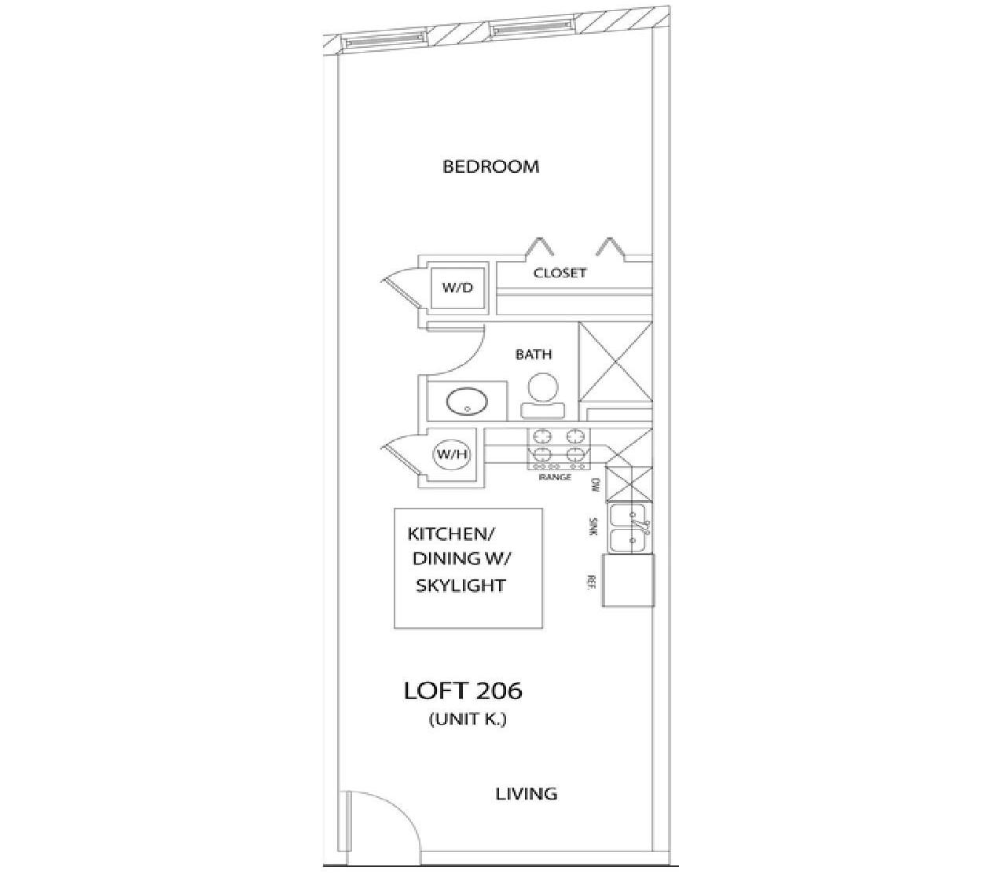

LIVING/DINING
12´ 2´´ X 44´ 7´´

BEDROOM
13´ 6´´ X 10´ 0´

LOFT 207
2 BEDROOMS 2 BATHS 1175 Sq. Ft.

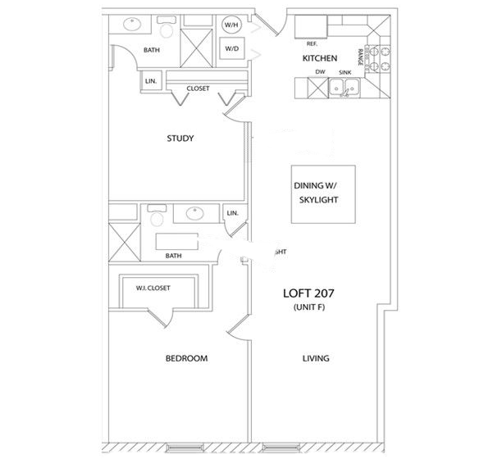
BEDROOM
13´ 5´´ X 13´ 4´´
LIVING/DINING
12´ 2´´ X 44´ 7´´

SKYLIGHT
STUDY
13´ 5´´ X 10´ 8´´

LOFT 208
2 BEDROOMS 2 BATHS 1161 Sq. Ft.

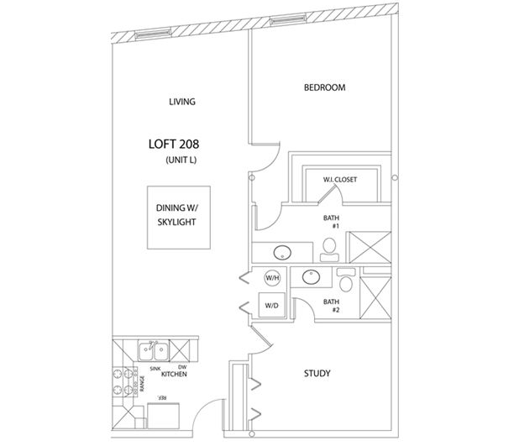

SKYLIGHT
STUDY
10´ 8´´ X 10´ 0´´
BEDROOM
13´ 9´´ X 12´ 7´´

LIVING/DINING
13´ 9´´ X 38´ 2´´

LOFT 209
2 BEDROOMS 2 BATHS 1231 Sq. Ft.

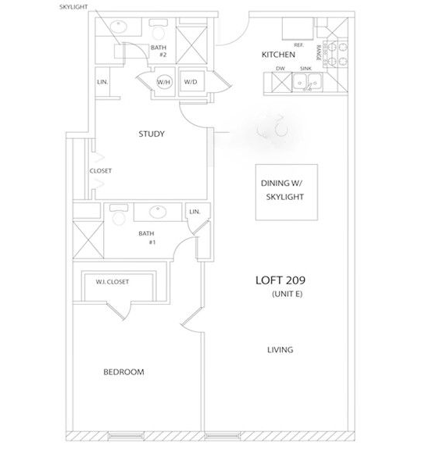

LIVING/DINING
14´ 3´´ X 44´3´´
BEDROOM
11´ 96´´ X 13´ 4´´

SKYLIGHT
STUDY
10´ 8´´ X 10´ 7´´

LOFT 210
2 BEDROOMS 2 BATHS 1170 Sq. Ft.

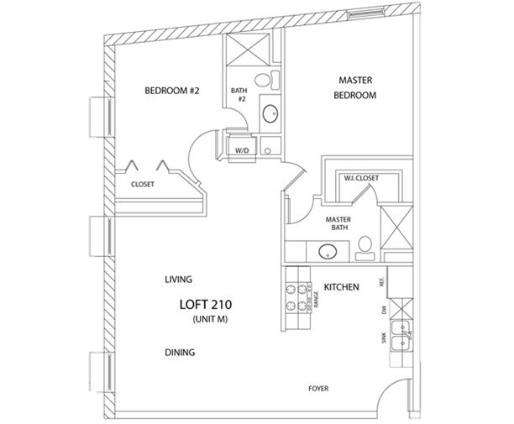
MASTER BEDROOM
12´4´´X 11´7´´

BEDROOM
10´1´´X 12´7´´

LIVING/DINING
28´1´´X 17´4´´

